SOLVING ONE STEP EQUATIONS
Pearson Edexcel - Tuesday 12 June 2018 - Paper 3 (Calculator) Higher Tier
1.
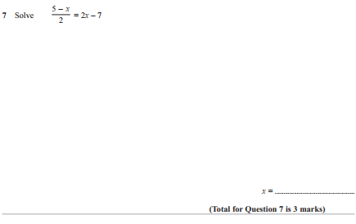
Pearson Edexcel - Thursday 26 May 2016 - Paper 1 (Non-Calculator) Higher Tier
2.
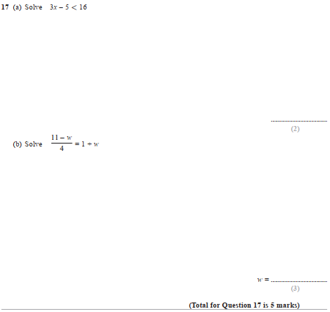
Pearson Edexcel - Thursday 4 June 2015 - Paper 1 (Non-Calculator) Higher Tier
3.
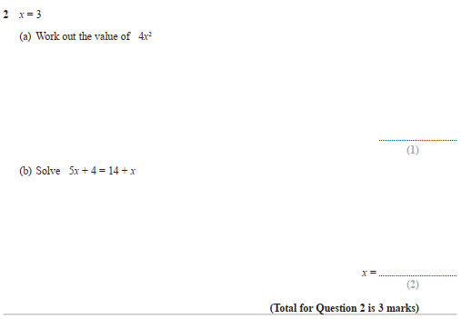

Pearson Edexcel - Monday 11 June 2012 - Paper 1 (Non-Calculator) Higher Tier
4.
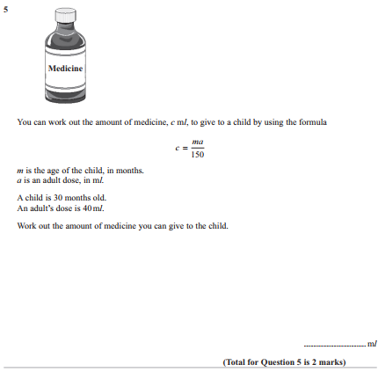

Pearson Edexcel - Friday 2 March 2012 - Paper 3 (Non-Calculator) Higher Tier
5.
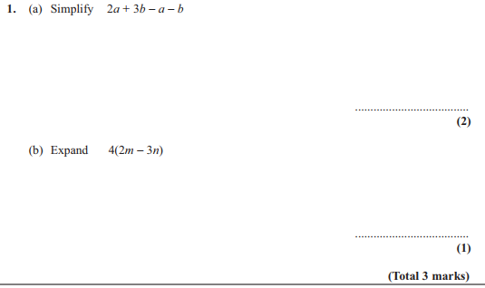
Pearson Edexcel - Friday 2 March 2012 - Paper 3 (Non-Calculator) Higher Tier
6.
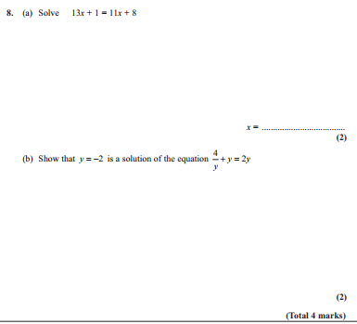
Pearson Edexcel - Monday 6 June 2011 - Paper 3 (Non-Calculator) Higher Tier
7.
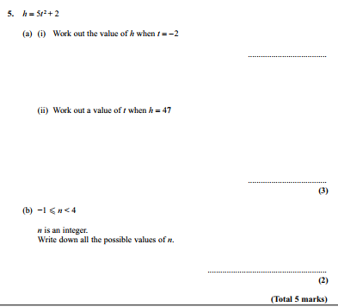
8.

